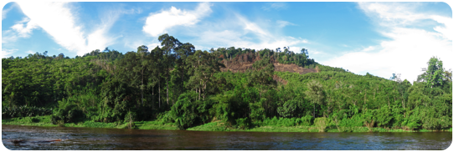

Hi. My first name is Mark, and my last name is Kuroski. I guess I should also say that my middle name is David, in case you were wondering. When I was a kid I wanted to be a paleontologist, then a few years later I had dreams of becoming a video game programmer. In the end I chose the logical path between both of these careers...a musical theatre actor, and as a musical theatre actor I can honestly say that I never imagined my skill set taking me to the island of Borneo where I would fight for the rights of indigenous people, work to stop deforestation, and save orangutans in captivity.
To be chosen as an eco-warrior, everyone interested had to create a two minute video explaining why they were the right person for the job. I don’t have an environmental background, but I do have a background in music, performance, and digital video so I decided to sing my application and edit together a fun little music video.
It’s been quite a journey since I submitted that video close to a year ago. I’ve met some of the most incredible people I’ve ever known, and seen things that I thought I would never see.
I’ve never even been much of an outdoors person. My parent’s would take me on nature walks as a kid, and the whole time I’d just be looking forward to going back home so I could play my newest video game.
As an adult I still feel more comfortable behind my computer screen, safe from giant flying beetles and poisonous snakes, rather than being outdoors under the glare of the burning sun...but Borneo is the adventure of a life time. It’s the kind of adventure that I’ve read about in my favorite books, and it’s the kind of adventure that changes a person.

Twenty days of the journey into Borneo have already come to pass, and it’s some of the events of those twenty days I’d like to share with you in this blog; however, there is so much more that I could write about! Borneo is a magical land, filled with beautiful people. Words just can’t do it justice.

Borneo

September 2011

Hello Friends:

This is my personal blog filled with my thoughts and impressions of my first 20 days in Borneo. I hope you enjoy the read!

Whoa, Oh, Oh, Oh Borneo!!!

A musical theatre actor travels deep into the jungles of Borneo as a member of DeforestACTION. Running from bugs and falling through bridges...did he survive the journey?

