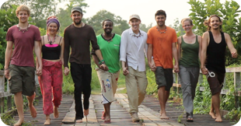
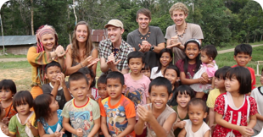
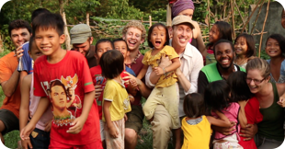
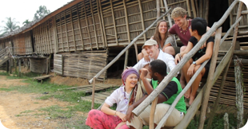

Here we are walking across another bridge. This one was made for vehicles to pass over; however, if this had been after the other bridge collapsed I would not have dared getting this shot! There are five countries represented in this picture all holding hands and walking in step which I think makes for a pretty cool photo...and luckily we didn’t break this bridge! By the way, DeforestACTION donated money towards rebuilding the bridge that we did break.

I like this shot because we are all pounding our fist in solidarity, standing up to the illegal palm oil companies! You may have noticed that I’ve had to change my outfit due to falling through a bridge into an empty riverbed filled with mud. It was so much fun hanging out with my fellow eco-warriors and all the kids. Trying to communicate to them across the language barrier what we were supposed to do during each shot was the most fun game of charades I’ve ever played!

I can count ten and a half smiles in this photo, but in actuality there are over twenty smiling, laughing faces. This was a hilarious shot! Eco-warrior Paul stood behind the camera and gave the cue for the group of kids to come running towards us...and let me tell you that when a group of beautiful Dayak children run directly towards you it’s impossible not to smile! However, this is also a sobering photo because as it was taken three kilometers away bulldozers are destroying the forests these kids and their families depend on.

Is it possible to become life long friends with a group of complete strangers in twenty days? ABSOLUTELY!! My fellow eco-warriors are some of the most diverse, passionate, caring, and fun people I’ve ever known. The expertise each person brings to this project is incredible, and the respect we have for each other keeps us connected even when we are spread across the planet. For the rest of my life Borneo will be in my heart...and so will this amazing group of people.

Photo by Paul Daley

Photo by Paul Daley

Photo by Paul Daley

Photo by Anne-Sophie Marion

